

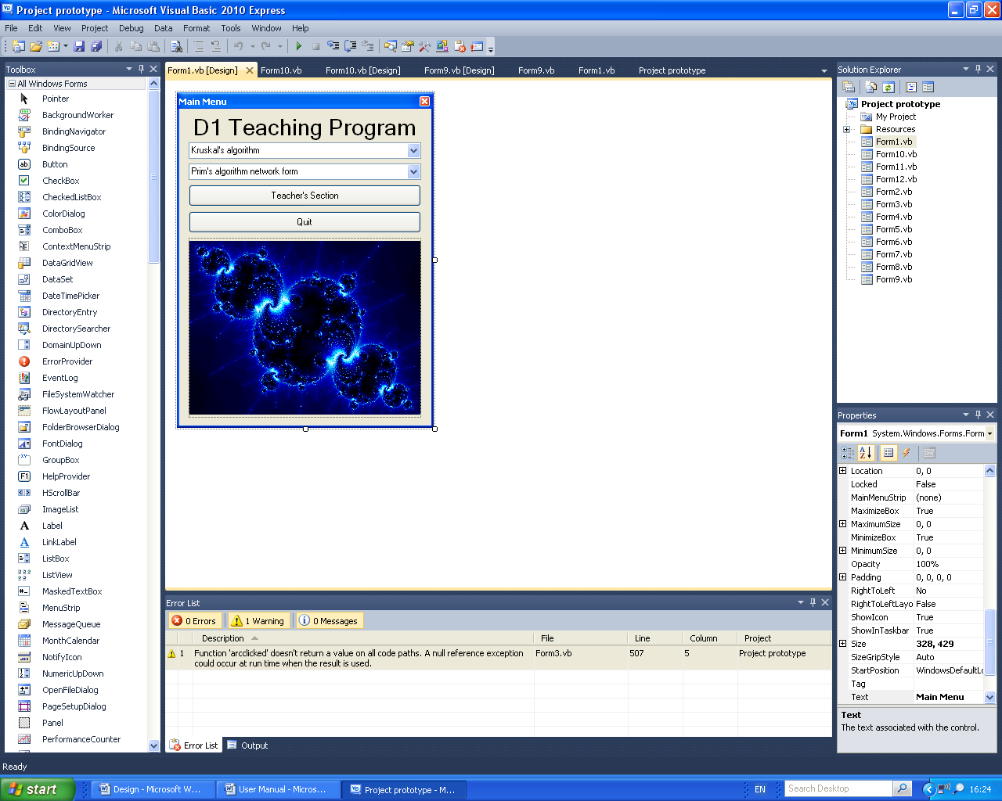

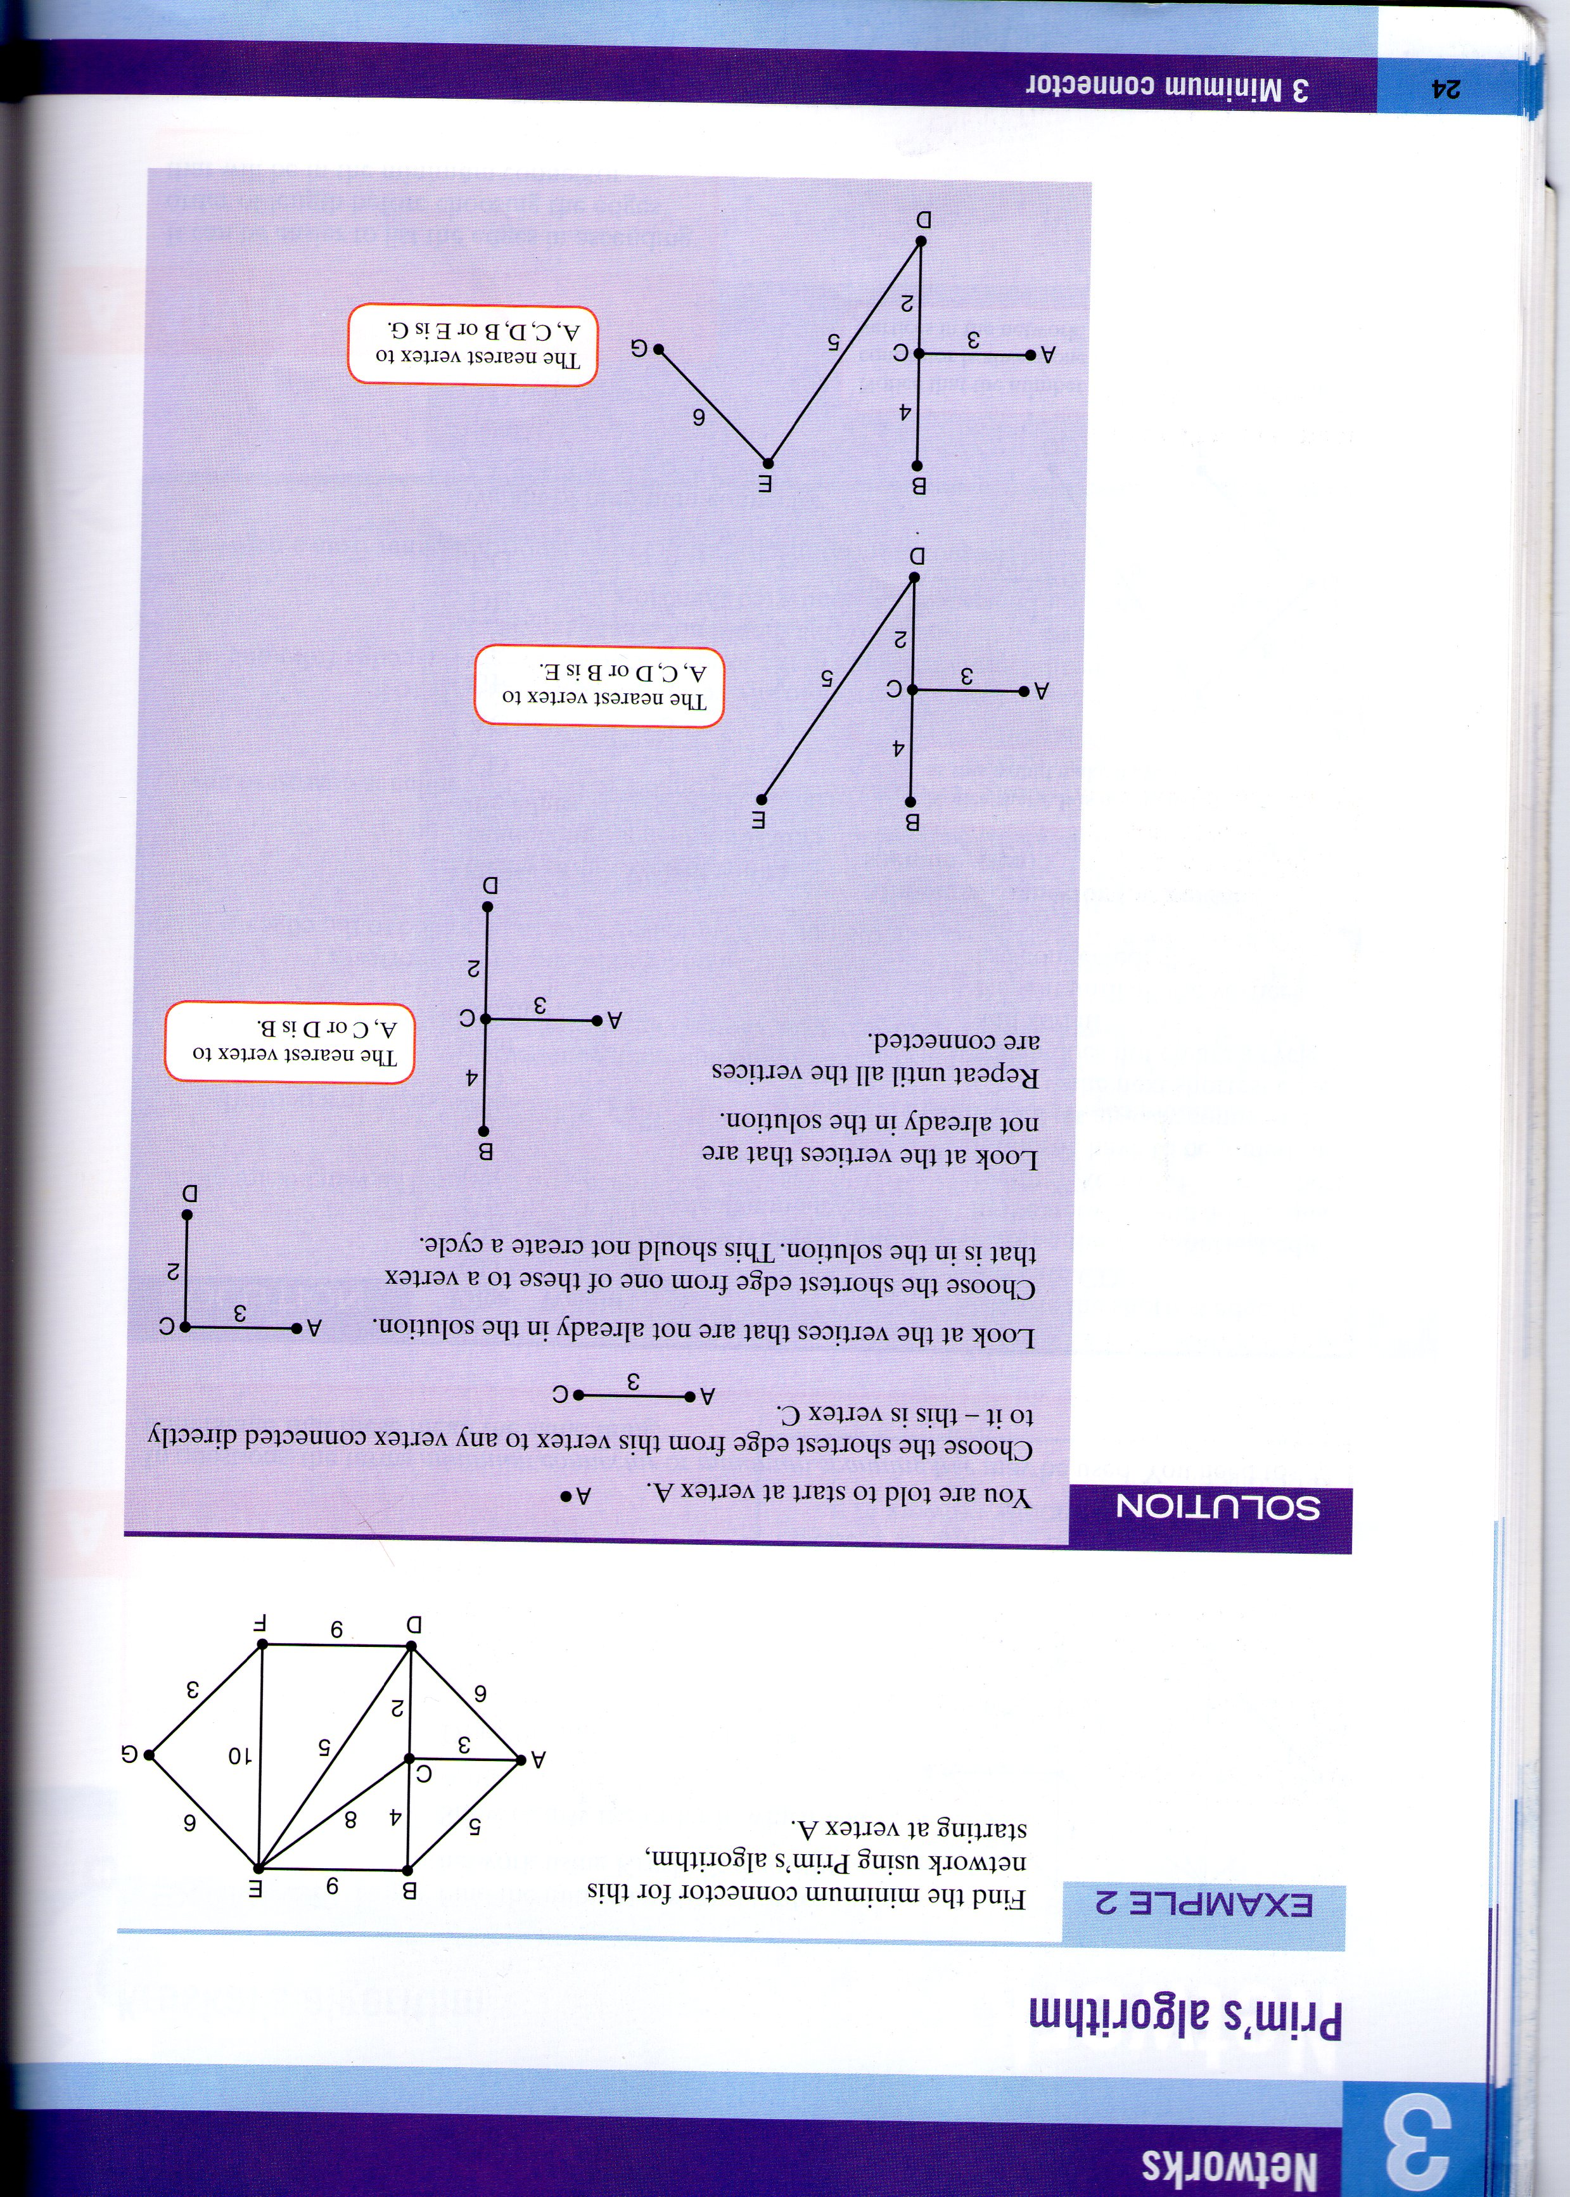

Contents

Introduction 1

Installation instructions 2-3

Main Menu 4

Kruskal’s: Run 5-6

Kruskal’s: Timed Run 7-10

Kruskal’s: Times Achieved 11

Teacher’s section: Login 12

Teacher’s section: Menu 13

Teacher’s section: Kruskal’s 14

Error messages and error recovery procedures 15-16

Introduction

This is the user manual for the ‘Decision Mathematics 1 teaching program’, which teaches users how to apply and use Kruskal’s algorithm to find the minimum connector of a network.

The teaching program is primarily for students and teachers of AS and A level Mathematics and Further Mathematics, however it can also be used by AS and A level Computing students and teachers. However it can only be used by students at Yeovil College and those who are enrolled in the D1 Mathematics course because this contains the main users of my program and therefore make it more useful.

However I have a few words of warning, if you use this program don’t give it to anyone else because this could compromise certain users identities. Also this is only a study aid and should be used in conjunction with the textbook and the revision guide and not as a replacement. However it can be used without the D1 textbook and the D1 revision guide but you will need it to get the best understanding of the algorithm.

Installation instructions:

You will need either a Windows XP, Windows Vista or Windows 7 computer or higher; below what one of the pages looks like in my program on Windows XP computers and Windows 7 computers:

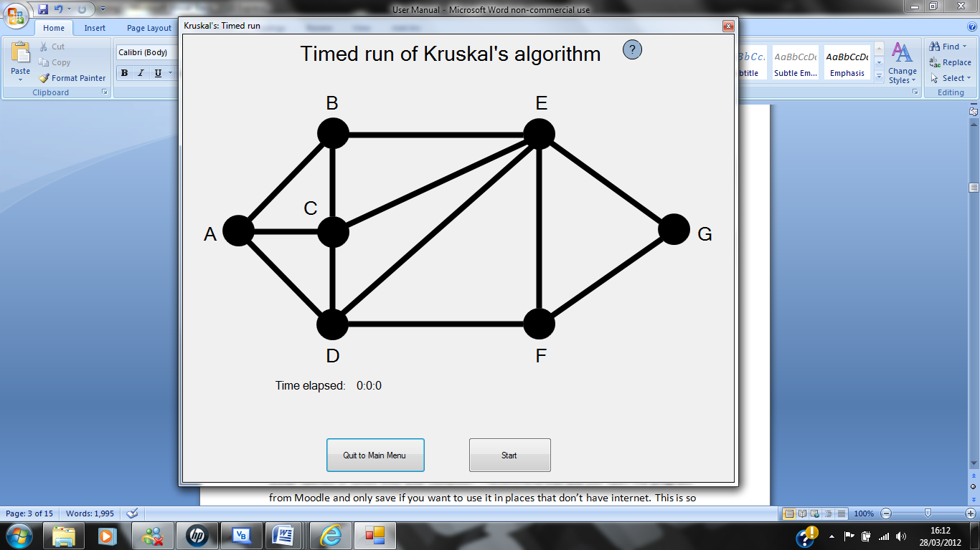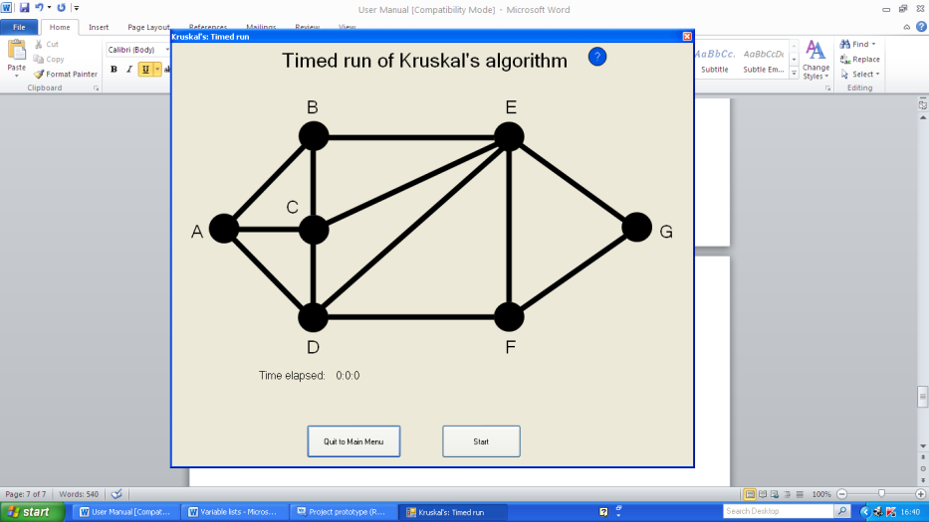Look of the timed run page on Windows XP: Look of the timed run page on Windows 7:

You can access this program from Yeovil Colleges Moodle on the Decision Mathematics 1 course. You can access this course if you have the password which all of Yeovil Colleges Maths teachers have or you can get them to enrol you in the course. The program can be either opened or saved onto your computer, I recommend that you just open the program from Moodle and only save if you want to use it in places that don’t have internet. This is so that the changes that you make to the leader board when you do a timed run will be able to be seen by others who use the program so that it will encourage others to do their timed runs quicker. To open or save the program onto your computer you will need to download VB.Net 2010 from this website: <http://www.microsoft.com/visualstudio/en-us/products/2010-editions/visual-basic-express> then press the install now button and then click on the “Run” button on the message box that is loaded; then follow the onscreen instructions. This installation process will take about 10-20 minutes and can be stopped at any point by pressing the cancel button during the installation process and continued at a later date. Also the installation software will ask you if you want to download extra files to improve the experience of Visual Basic, however this is not needed to use my program so you are better off in just installing the Visual Basic 2010 express package.



This is the install now button which you must press to begin the installation process.

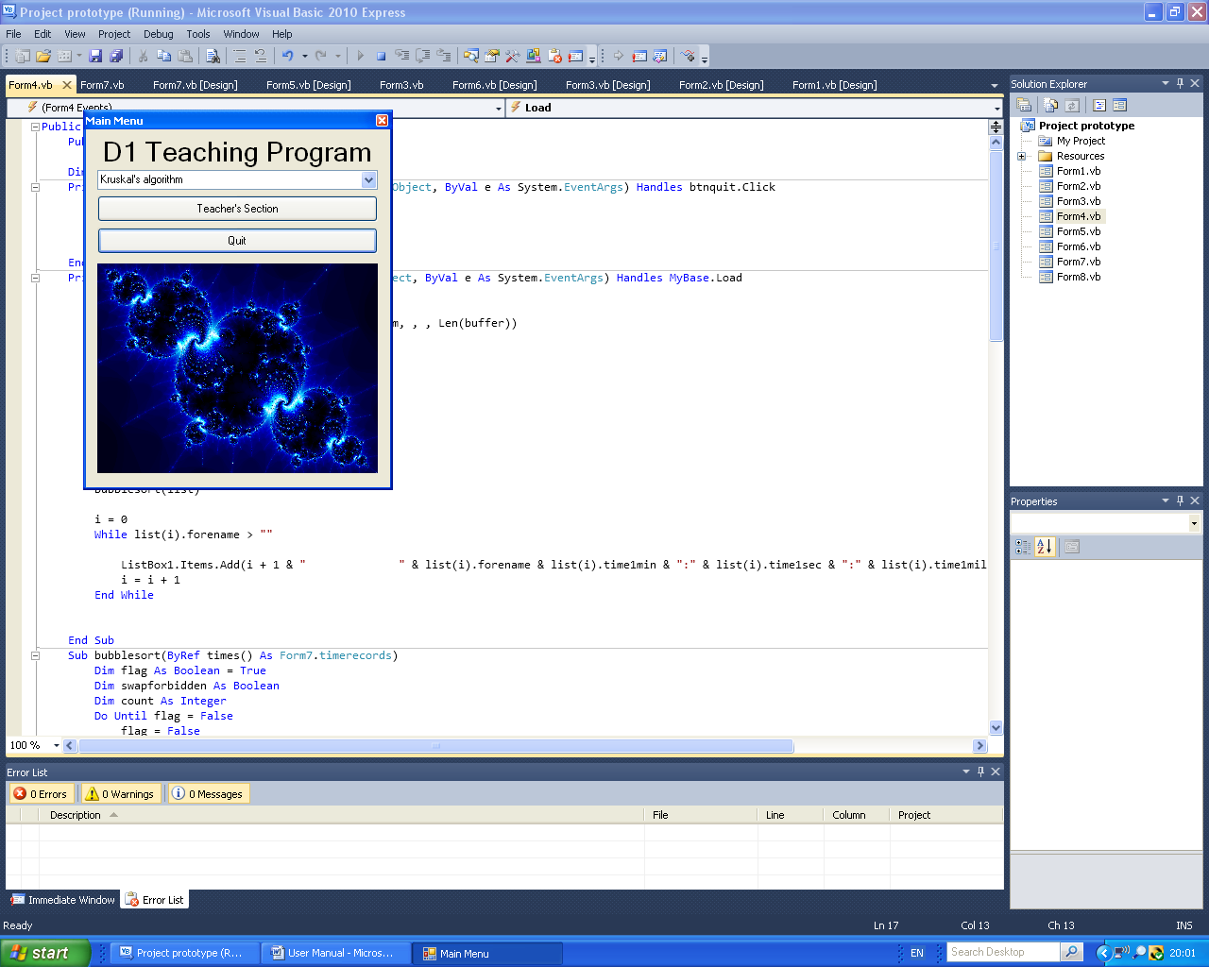Main Menu

This is the drop down button that will show the three pages that you can go on to that are on Kruskal’s algorithm.

This is the button that you press (if you are a teacher) to go to the Teacher’s section: login page.

This is the button that you press when you want to quit the program.

This is a fractal which is being used to add colour and excitement, however it is not strictly to do with D1 but they are made using computers.

When you press the drop down button a box appears which shows the three options that you can choose these being “Run”, “Timed Run” and “Times Achieved”.

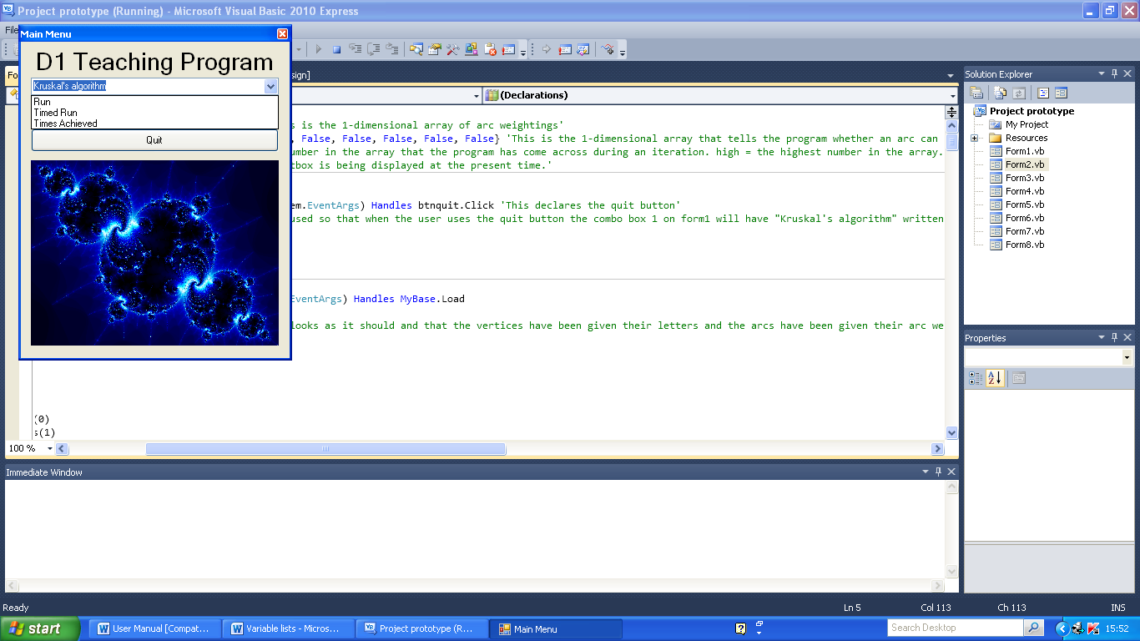

Kruskal’s: Run

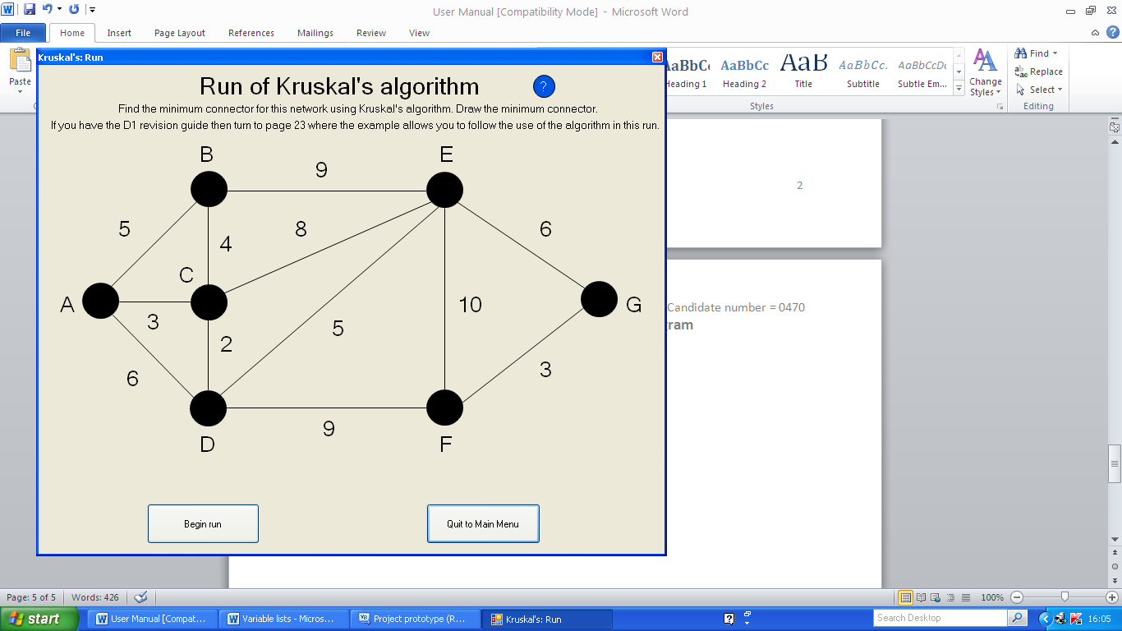Starting page:

This button begins the run of Kruskal’s algorithm when pressed.

This button takes you back to the main menu. This can be pressed before you start the run or after.

Help button: When pressed a box will be displayed that displays the steps of Kruskal’s algorithm. Use this if you are stuck.

To gain an even better understanding of the application of Kruskal’s algorithm perform the run using the D1 revision guide and or textbox. If you haven’t got either of these speak to your Maths teacher. However if you don’t have these two books don’t worry as this is also designed to be used without them.

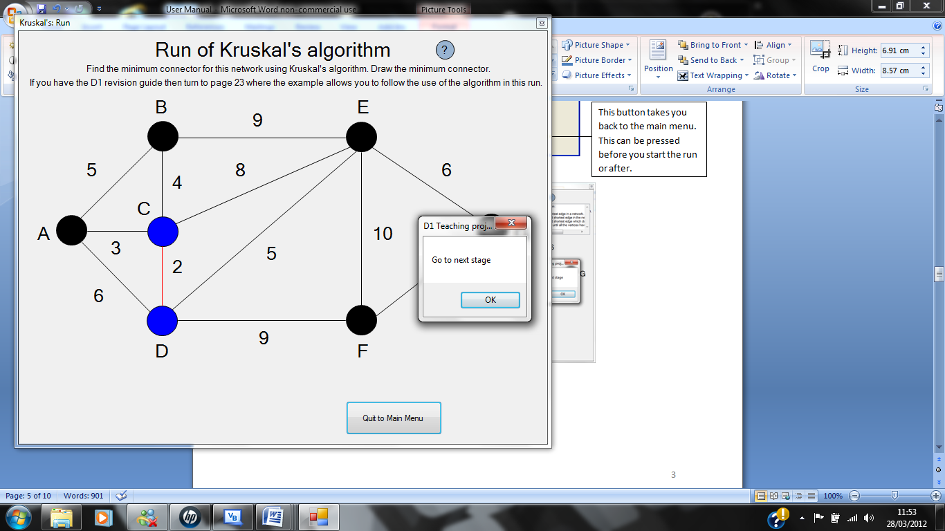

Once you have pressed the “Begin run” button the run of Kruskal’s algorithm will begin where it will start by colouring the first arc that is in the minimum connector. To move onto the next stage you must either press the “OK” button on the message box or press the Enter/Return key. In both the timed run and the run pages the arcs that are in the minimum connector are coloured red and the vertices that the arcs are connected to are coloured blue, so that you know that these vertices have been connected in the minimum connector.

The network and question for the run of Kruskal’s algorithm is taken from the example in the D1 revision guide on page 23, so it would help your understanding of the algorithm if you have this book. However it is not a necessity that you have it to get the best out of my program.

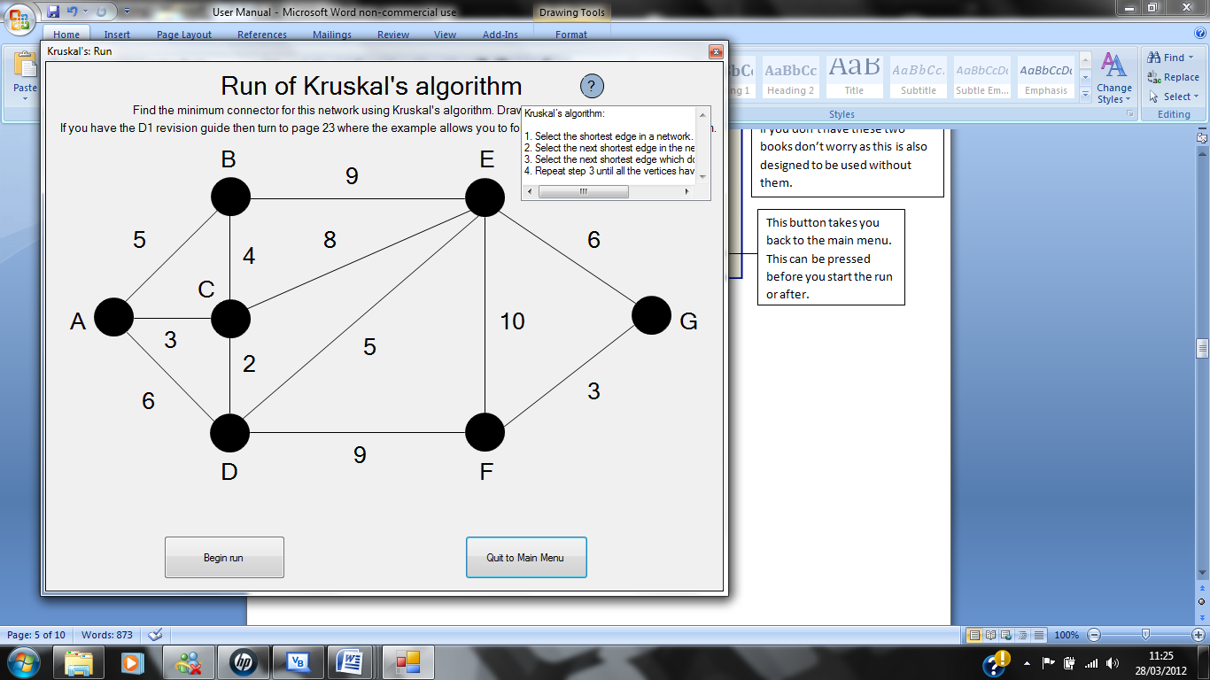Help button:

This is the help button and when it is pressed it displays this.

This is a list box which displays the 4 steps of Kruskal’s algorithm. This is to help you to figure out what to do if you get stuck.

This is designed so that it looks like the Microsoft office help button so that you will know what it is for without looking at the manual.

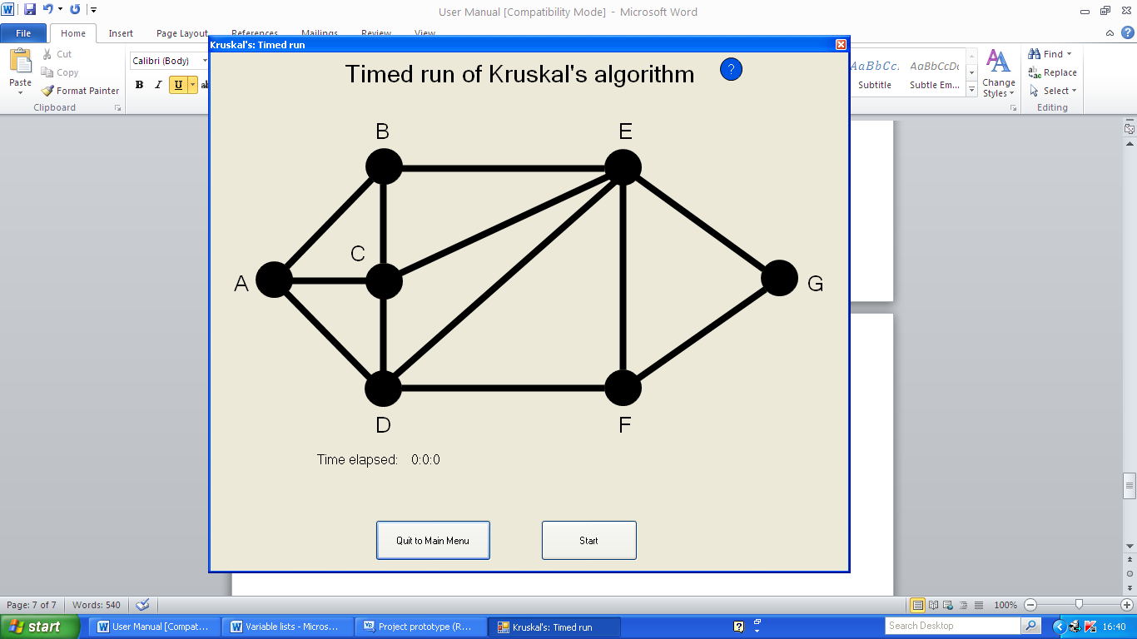Kruskal’s: Timed Run

Help button: When pressed a box will be displayed that displays the steps of Kruskal’s algorithm. Use this if you are stuck.

The arc weights are not shown before the user presses the “Start” button. This is so that users can’t cheat as they won’t know what the network looks like before starting the timed run.

This button starts the timer and begins the timed run of Kruskal’s algorithm.

When this button is pressed the program closes this page and instead displays the Main Menu.

This shows the time that has elapsed since the start button was pressed in minutes, seconds and milliseconds.

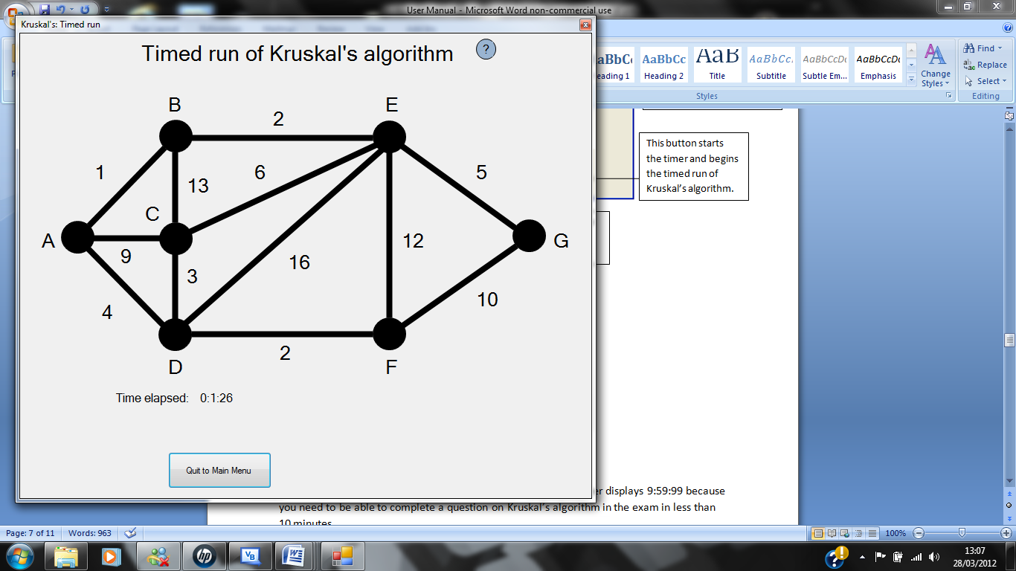This is displayed once you have pressed the “Start” button:

Nothing happens if you click on the vertices.

These arc weights will be different each time this page is opened as they are generated using a random number generator.

From this point forward you can click on the arcs that you think are in the minimum connector in the correct order. If the arcs you chose turn red then you have clicked on the correct arc.

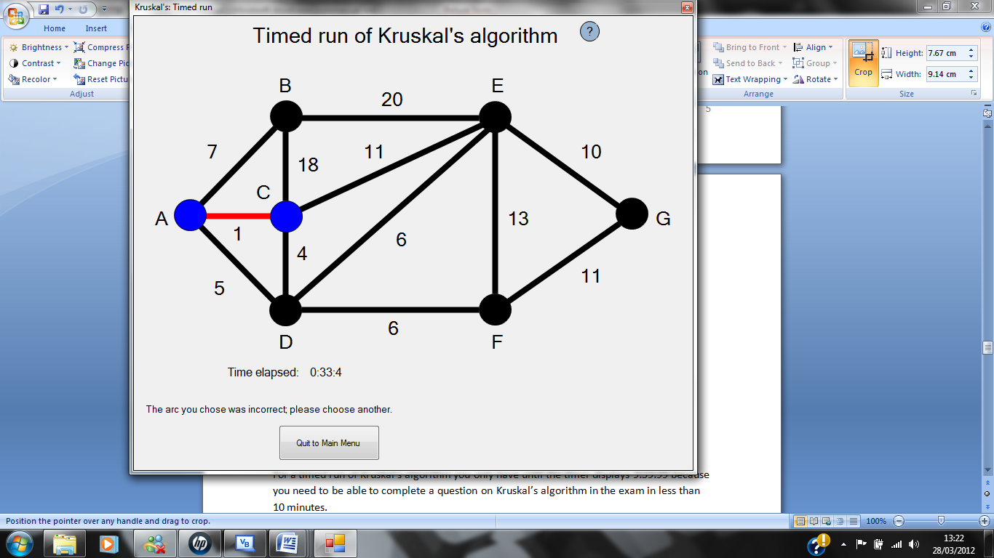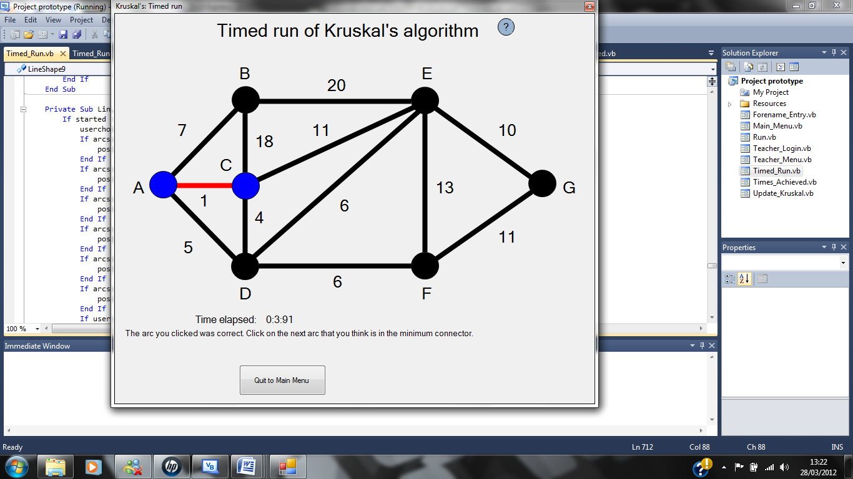

If the arc you clicked was correct then this message will be displayed.

If the arc you clicked was incorrect then this message is displayed.

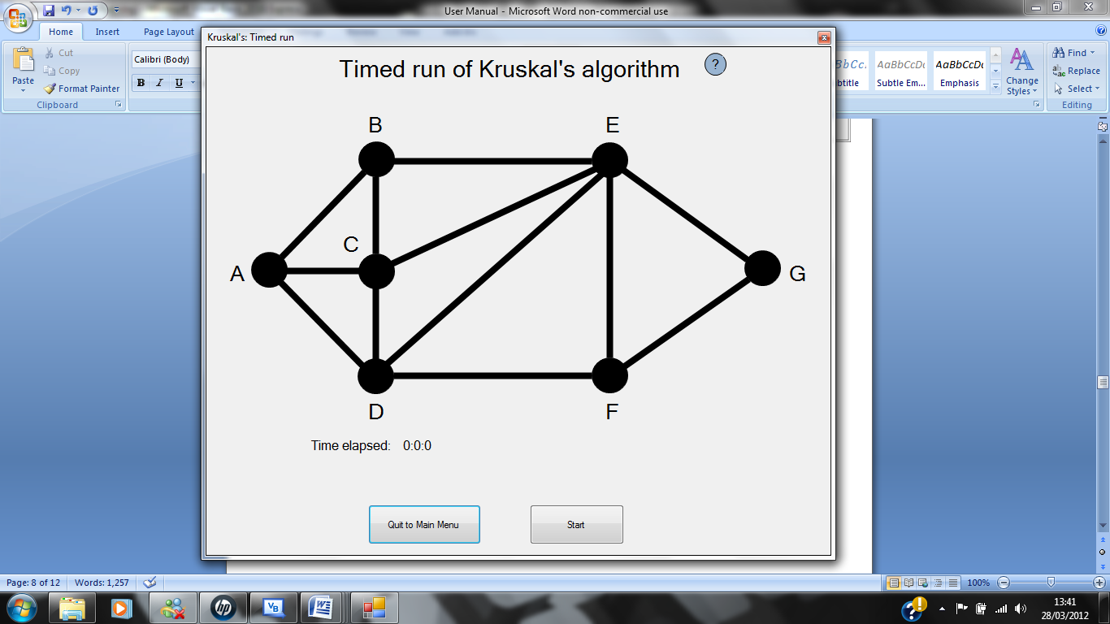In the program there is a slight issue with the selection of the correct arcs to go into the minimum connector because if there is two or more arcs that have the same arc weight and two or more of these suppose to be in the minimum connector of the network, then the program will ask for you to pick the arc that has the highest position number in the array in the program code. Whereas when you perform Kruskal’s algorithm on paper it doesn’t matter which one you choose and in which order but this problem was thought of as being minor during program development. The position numbers for each arc are shown below so that you know when there is a choice between two or more arcs with the same arc weight then you can pick the right one (this being the arc that has the highest number next to it below out of the same weighted arcs that you have come across.) to move onto the next stage of the algorithm:

For a timed run of Kruskal’s algorithm you only have until the timer displays 9:59:99 because you need to be able to complete a question on Kruskal’s algorithm in the exam in less than 10 minutes. If you reach this time then you will be taken back to the Main Menu and the program will display a message box which states that you have failed to complete a timed run of Kruskal’s algorithm; however this is unlikely.

Once you have completed a timed run you are then taken to the forename entry page which is shown below:

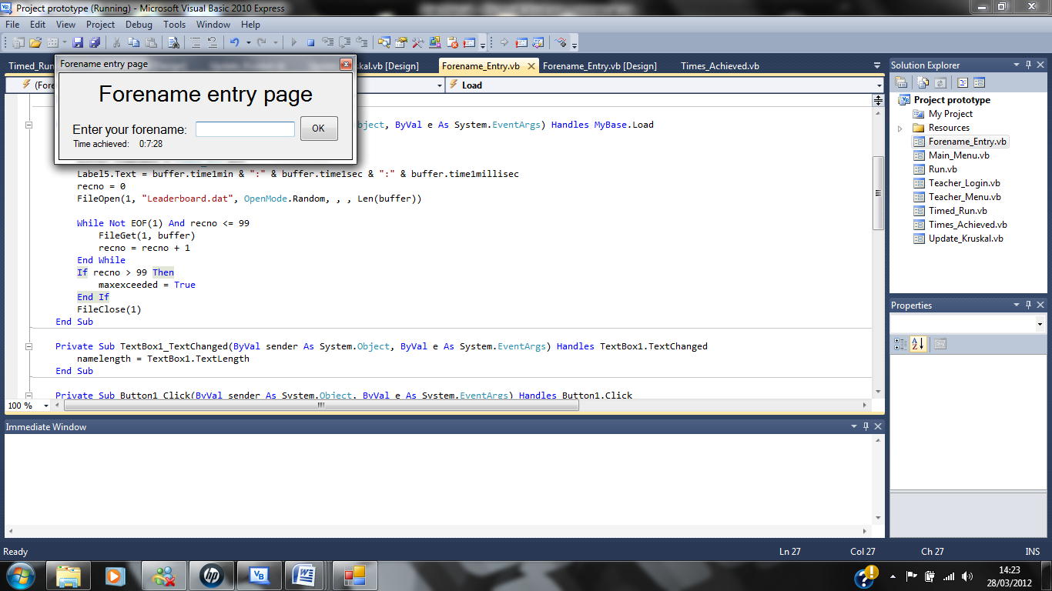

Press this button once you have entered a forename into the text box.

You have to enter at least your forename or another name into this box and then press the “OK” button. However you can’t enter a forename that contains no characters or contains over 50 characters. You can also enter your surname and middle name so that you can be distinguished from others users who have your forename; as long as you keep inside the boundaries stated. You can also enter numbers so that you could enter “John1” or “John2” to show that this is John’s 1st and 2nd timed run.

This is the time that has been achieved by the user.

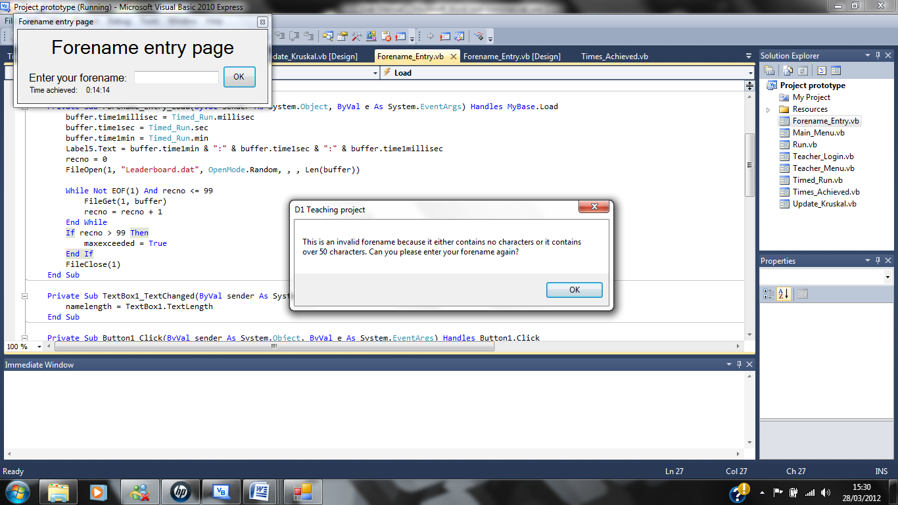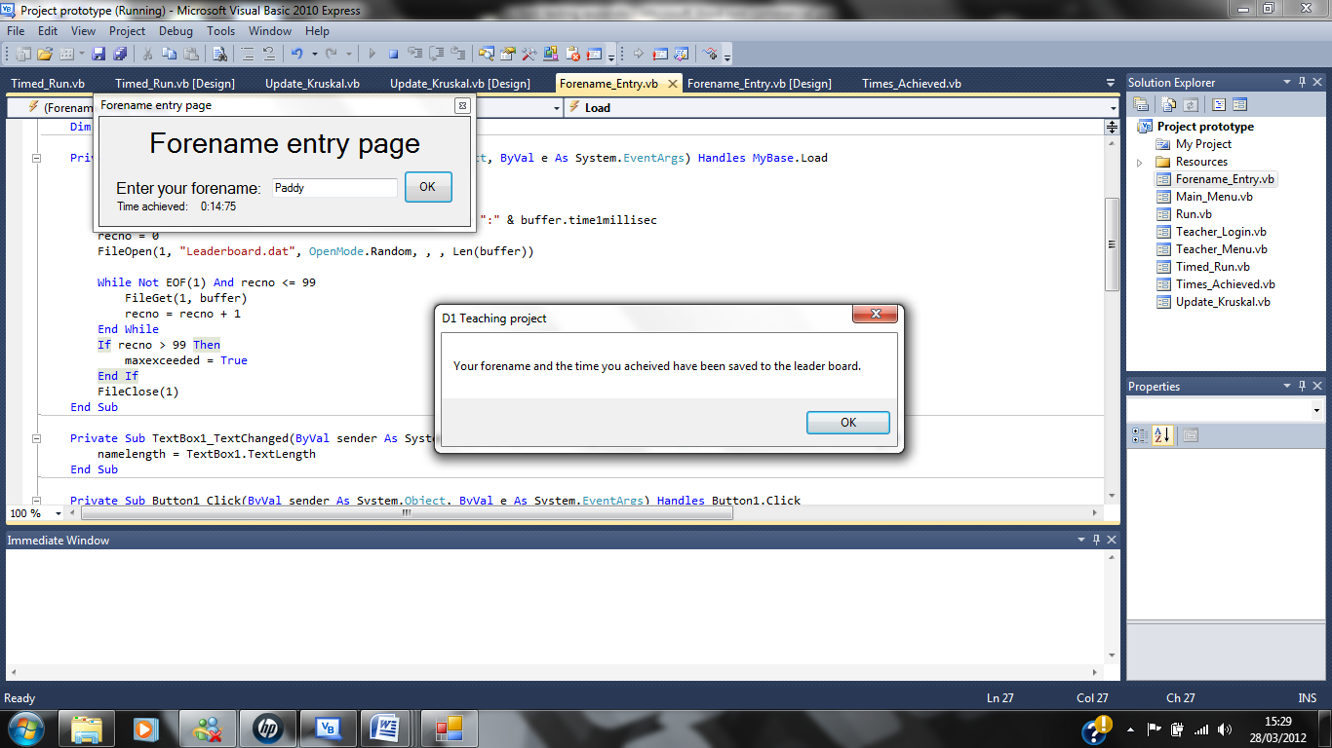Once you have pressed the “OK” button then the program will save the time achieved along with the forename entered into a file. You can see the time you achieved and where it puts you into the leader board by going into the page “Kruskal’s: Times Achieved”. However your forename and time achieved are only saved if the forename is accepted which is shown to you using a message box as is the same when the forename is not accepted. Both of the message boxes are shown below:

This is the message box that is displayed when your forename has not been accepted.

This is the message box that is displayed when your forename is accepted. After this is shown and you press the “OK” button you will be taken back to the Main Menu.

When the number of records saved into the file reaches 100 the program will not save any more records until some are deleted. This is to prevent users from saving too many of the times that they achieve. A message box will be displayed to you once the number of records in the file reaches 100 so that it doesn’t save 101 records or more. This message box will tell you that you must contact a Maths teacher at Yeovil College so that they can delete records because you won’t be able to save any more records until this is done, however you will be able to look at the times achieved page and the update Kruskal’s page so that you can look at the leader board and my end user can delete files.

If you wish to have your times achieved deleted then you can do this by contacting a Maths teacher at Yeovil College, however your times achieved will be deleted once you are no longer a student of Yeovil College by the Maths department.

Kruskal’s: Times achieved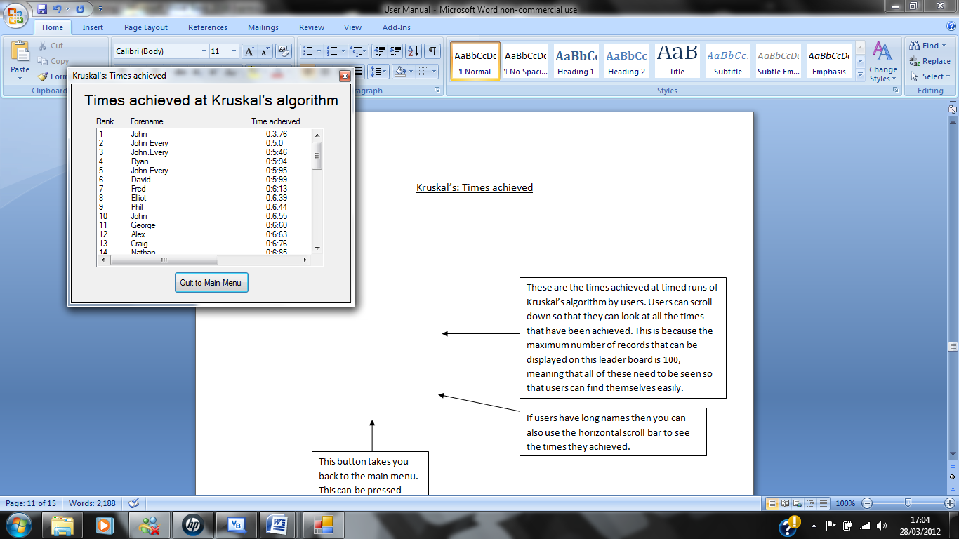

These are the times achieved at timed runs of Kruskal’s algorithm by users. Users can scroll down so that they can look at all the times that have been achieved. This is because the maximum number of records that can be displayed on this leader board is 100, meaning that all of these need to be seen so that users can find themselves easily.

If users have long names then you can also use the horizontal scroll bar to see the times they achieved.

This button takes you back to the main menu. This can be pressed before you start the run or after.

This page of the program is designed to be simple to understand and is only used for looking at other times achieved by user, so that others users can see their friends time and try and beat it. This is designed to aid competition so that users will have more of a determination to improve their time and what is more fun than a bit of friendly competition.

On both this page and the Teacher’s section: Kruskal’s page the times achieved are displayed like this: 0:0:0(In minutes, seconds and milliseconds, therefore if a user does a time of 0:6:3 then they completed the timed run in 6 seconds and 3 milliseconds which is faster than the time of 0:6:30 where a user would have completed the timed run in 6 seconds and 30 milliseconds. If you want to do well in the exam at Kruskal’s algorithm questions then you should try and complete the timed run in under a minute so that you will give yourself plenty of time in exam questions as more workings out are needed to do exam questions than the timed run in my program.

A blank record is produced in the leader board shown on this form and the Update_Kruskal form; just ignore it.

Teacher’s section: Login

The following teacher’s section tutorials are only for teachers and not for students therefore if you are a student then you don’t need to read the information about the teacher’s section.

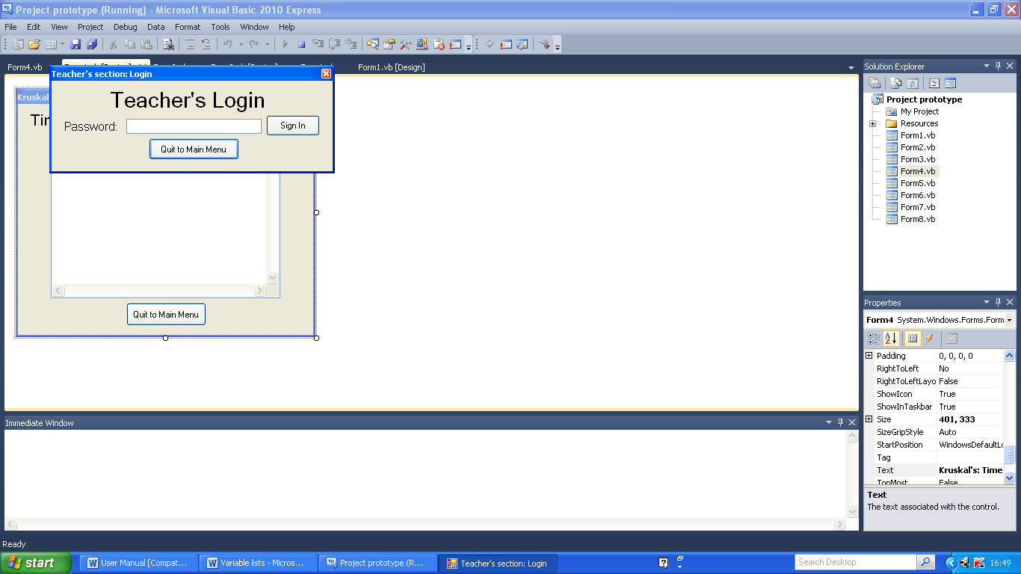

This is the “Sign In” button which when pressed will allow you entry to the teacher’s section; if you entered the correct password into the password entry box.

This is the password entry box which the password needs to be entered in to.

This button takes you back to the main menu.

If the password entered is at all different from the password in the coding then you will be denied access to the Teacher’s section of my program. If you are a teacher and you want to access the Teacher’s section then talk to Andy Bradley and he will give you the password to enter.

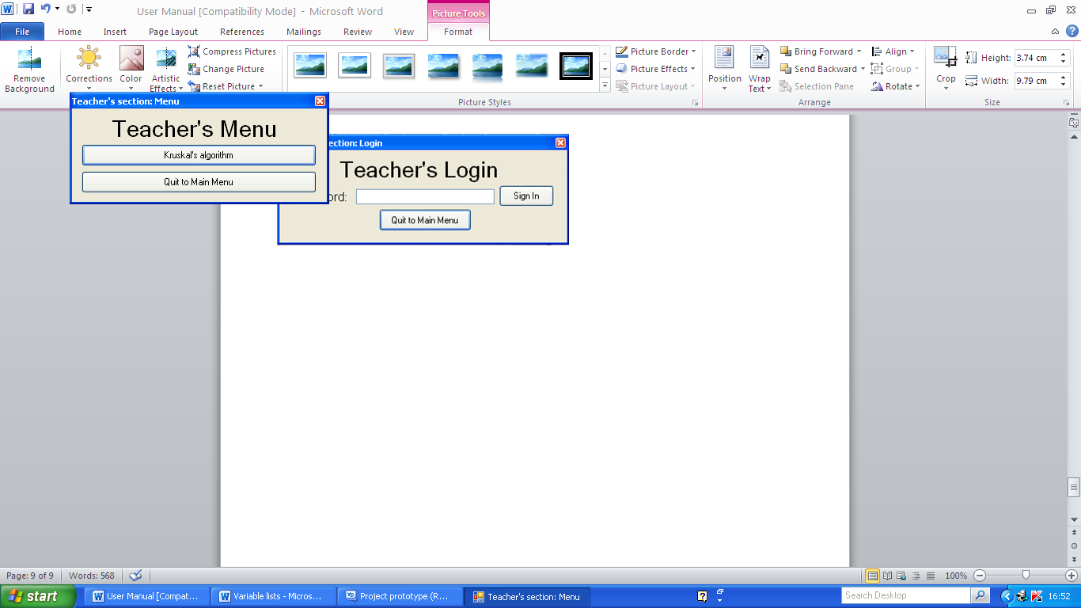Teacher’s section: Menu

This button takes you to the page where you can change the leader board of times achieved by users.

When this button is pressed the user is taken back to the Main Menu page.

This menu is only for teacher’s use once they have signed in and the password they entered has been accepted. This menu can be easily adapted for when this program is changed to incorporate more of the D1 syllabus that is why there is only one option that you can choose to go into instead of just going back to the Main Menu.

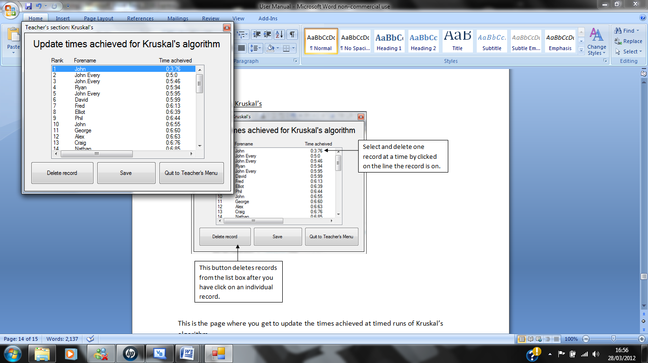Teacher’s section: Kruskal’s

Select one record at a time by clicking on the line the record is on.

This is the “Quit to Teacher’s Menu button which takes the user back to the Teacher’s Menu.

This button saves the changes to the leader board and deletes the files that have been deleted from the list box permanently. You can permanently delete as many records as you want from the leader board.

This button deletes records from the list box after you have clicked on an individual record.

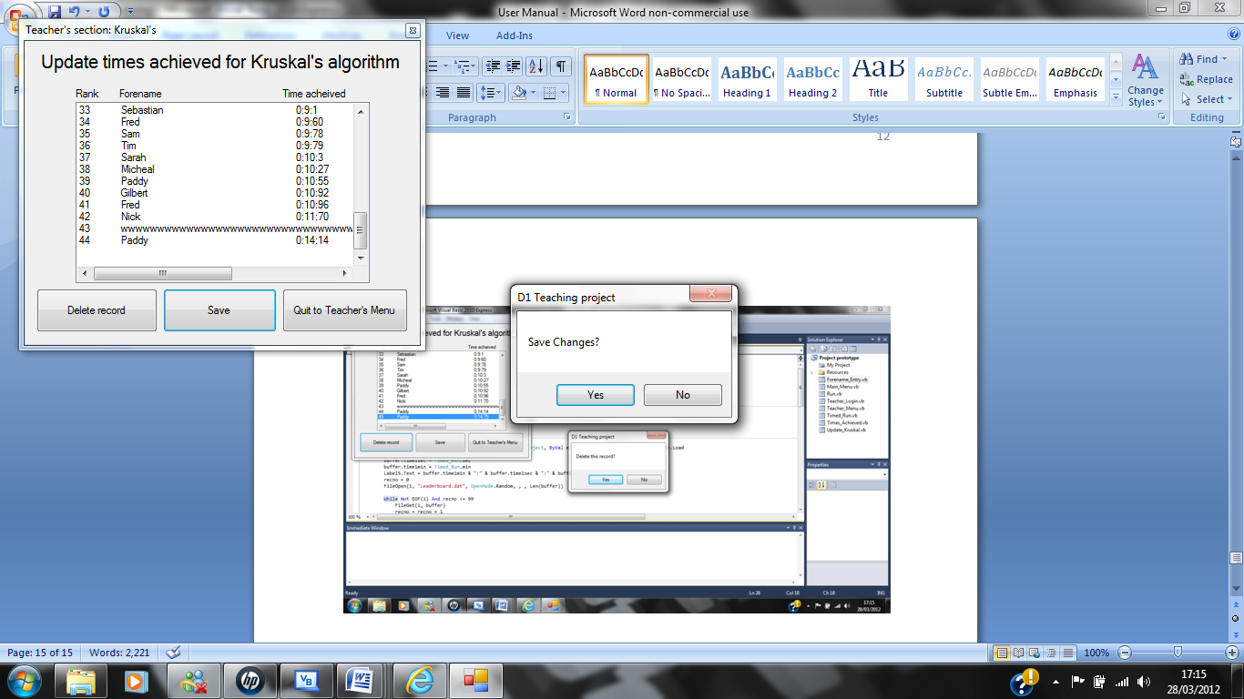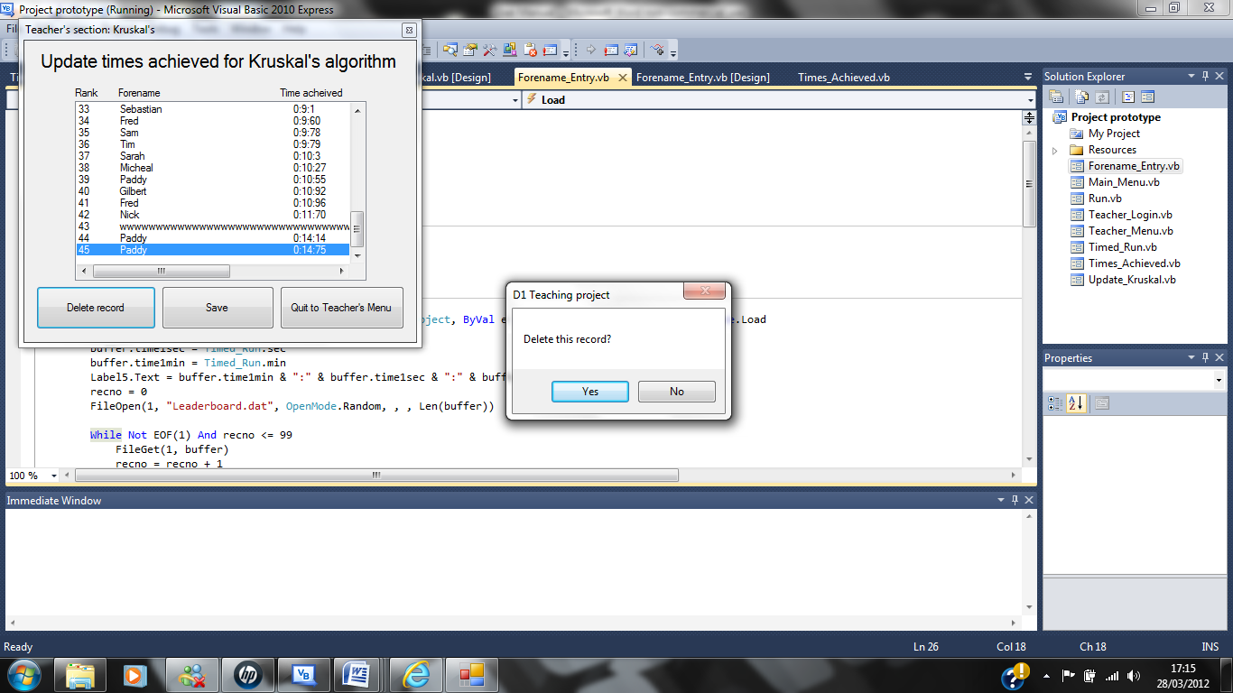This is the page where you get to update the times achieved at timed runs of Kruskal’s algorithm. Before the “Delete” button deletes the record selected and before the “Save” button saves the changes made to the leader board a notification message box appears for both circumstances; these are shown below:

This is to prevent any records from being deleted or being permanently deleted accidently by teachers.

Error messages and error recovery procedures

Due to there being bugs in the coding software that I used to make this program(VB.Net 2010) during timed runs there may be cycles that are allowed and appear, incorrect arcs being coloured or not being able to do a timed run at all. If this does happen or anything else happens that shouldn’t then exit the program immediately and reopen the program; the problem shouldn’t be one now, however if the problem persists then contact Andy Bradley or someone in the Computing department to fix it.

Below are the error messages that are displayed in my system along with why and where they appear and what you should do if they appear.

Error message What you should do

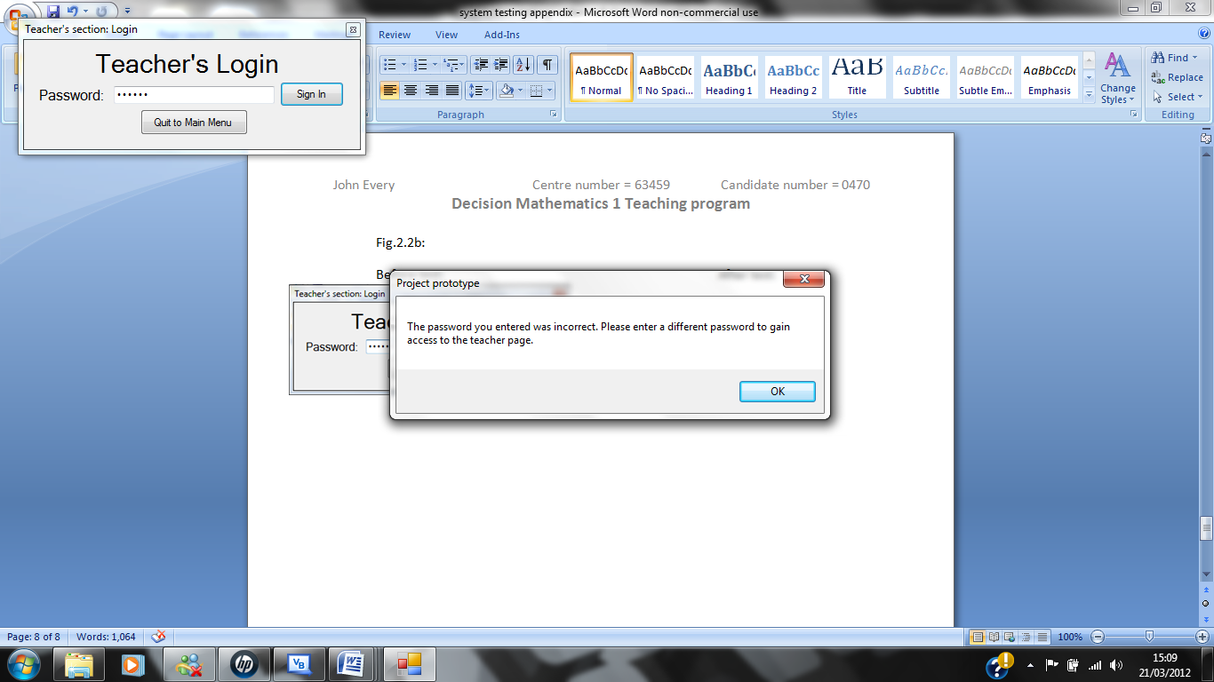This message box appears when you enter an incorrect password in the password entry box on the Teacher’s section: Login page. To fix this enter the correct password which you can obtain from a Maths teacher at Yeovil College.

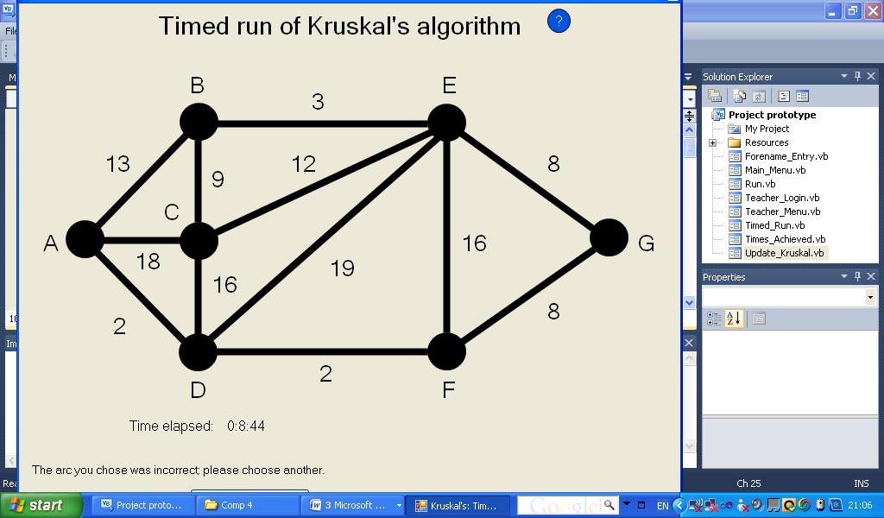This message box appears when you enter an invalid forename into the entry box on the forename entry page. An invalid forename is a name that contains no characters or a name that contains over 50 characters.

This is the error message that is displayed when you click on an incorrect arc to go in to the minimum connector. You can stop this by choosing the correct arc if you need help deciding on which arc to choose then use the help button or ask your Maths teacher for help.

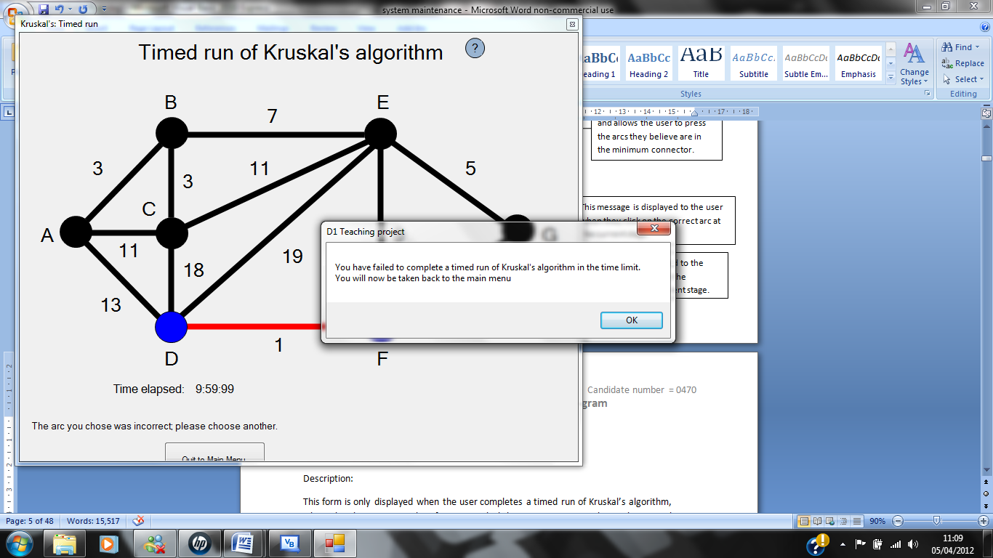 This is the error message that is displayed when you fail to complete a timed run of Kruskal’s algorithm due to you not being able to complete it in less than 10 minutes.

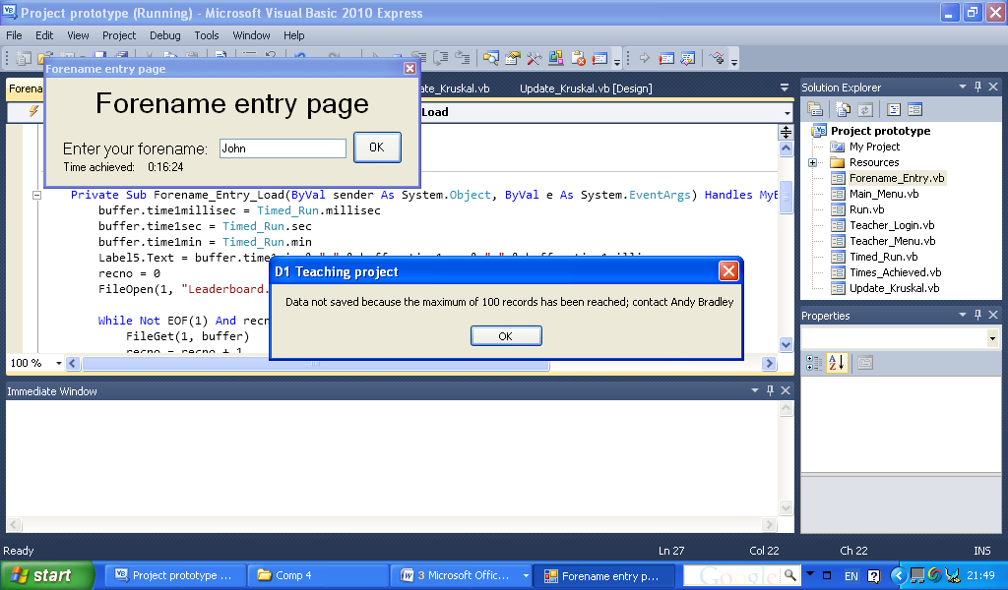 This is the error message that is displayed when the number of records in the file containing the leader board is tried to be made by you to go beyond its maximum of 100. This will mean that you won’t be able to save any more of your times achieved until some of the records have been deleted by a maths teacher.